Southminster Presbyterian Church
7th Sunday after Pentecost
July 7, 2024
9:30 a.m.

Find the link for the service on one of these sites:
1) on Facebook: https://www.facebook.com/SouthminsterGlenEllyn/
2) our YouTube channel:
https://www.youtube.com/channel/UCPgWICngOvkmR1OXgCG_wiA/live
3) our web site: https://www.southminsterpc.org/
If the video feed is interrupted during the service, we will continue to record and then post the full video on Facebook and our web site as soon as possible.

For those who are in the sanctuary, please put your phone in airplane mode.

Today we are having communion. Those at home may want to gather the elements (“bread” and “wine” or whatever you have) before the service begins.

Gathering Music

Our Photo Story today is “Summer Cooking.”

Welcome and Announcements
Lighting the Candles (Acts 2:2)‬‬‬‬‬‬‬‬‬‬‬‬
They devoted themselves to the apostles’ teaching and fellowship,
to the breaking of bread and the prayers.

Prelude

[Please remain seated while singing the opening song.]
Hymn: 10,000 Reasons (Bless the Lord) pg. 2, gold worship supplement

Call to Worship
Leader: We enter this sacred space to voice the longings of our hearts in prayer.
People: In a sacred company, we offer our love to the Eternal One.
All: Let us worship God!

Hymn 510: We Gather Here in Jesus’ Name (all verses)

Prayer of Confession: (unison)
Holy God, you have given us the gift of prayer to share life with you, but we often forget to turn to you. Help us to turn to you quickly and find our rest in you. We ask this in the name of Jesus Christ, our Lord and Savior. Amen.

(Time of silence for personal prayer and confession)

Declaration of God’s Grace/The Good News of Jesus Christ (Psalm 103)
Leader: The Lord is merciful and gracious;
slow to anger and abounding in steadfast love.
People: For as the heavens are high above the earth,
so great is his steadfast love toward those who fear him;
Leader: As far as the east is from the west,
so far he removes our transgressions from us.
People: In the name of Jesus Christ, we are forgiven!
All: Alleluia!

Response 582: Glory to God, Whose Goodness Shines on Me
Glory to God, whose goodness shines on me,
And to the Son, whose grace has pardoned me,
And to the Spirit, whose love has set me free.
As it was in the beginning, is now and ever shall be. Amen.
World without end, without end. Amen.
World without end, without end. Amen.
World without end, without end. Amen.
As it was in the beginning, is now and ever shall be. Amen.

Text Adapt. and Music ©2008 Paul M. Vasile
Reprinted/Streamed with permission under OneLicense.net #A-739517. All rights reserved.

The Passing of the Peace

Word with Children Blair Baldwin
Children worshiping in the sanctuary, please come forward.

As the children leave:
I Danced in the Morning (refrain) Hymnal 157
Refrain:
Dance then, wherever you may be;
I am the Lord of the Dance, said he,
And I'll lead you all, wherever you may be,
And I'll lead you all in the dance, said he.

CCLI Song # 78529
Sydney Bertram Carter
Words: Stainer & Bell Ltd; Music: Stainer & Bell Ltd
For use solely with the SongSelect® Terms of Use. All rights reserved. www.ccli.com
CCLI License # 21214429

Prayer for Illumination

Scripture Lessons: Hebrews 11:1-2, 32-40 Pew Bible, p. 225, 226 (N.T.)
Daniel 6:16-22 Pew Bible, p. 827 (O.T.)

Sermon: “Who do you think you are?”

Saying What We Believe/Affirmation of Faith (unison)
The Apostles’ Creed [Ecumenical]
I believe in God, the Father almighty, creator of heaven and earth.
I believe in Jesus Christ, God’s only Son, our Lord, who was conceived by the Holy Spirit, born of the Virgin Mary, suffered under Pontius Pilate, was crucified, died, and was buried; he descended to the dead. On the third day he rose again; he ascended into heaven, he is seated at the right hand of the Father, and he will come to judge the living and the dead.
I believe in the Holy Spirit, the holy catholic Church, the communion of saints, the forgiveness of sins, the resurrection of the body, and the life everlasting. Amen.

Hymn 509: All Who Hunger, Gather Gladly (all verses)

Offering of Ourselves and Our Gifts
[The offering plate is at the back of the sanctuary. Please leave your gift or pledge
in the plate on your way into or out of worship.]

Offertory: Lord, I Need You (pg. 31, gold supplement)

*Doxology Hymnal #606
Praise God, from whom all blessings flow;
Praise Him all creatures here below;
Praise Him above, ye heavenly host;
Praise Father, Son, and Holy Ghost. Amen.

Public domain

Prayer of Dedication

Service of the Lord’s Supper
Invitation
[You do not need to wait to consume the elements – please do so as the Spirit
leads (right away, as you pause after receiving, or back in your seats).
We extend an invitation to the Lord’s Supper to all who have been baptized. You do
not need to be a member of this congregation or a Presbyterian to share in this meal.
We remember that access to the Table is not a right conferred upon the worthy, but a
privilege given to believers who come in faith, repentance, and love.]

Great Prayer of Thanksgiving
Leader: The Lord be with you.
People: And also with you.
Leader: Lift up your hearts.
People: We lift them to the Lord.
Leader: Let us give thanks to the Lord our God.
People: It is right to give our thanks and praise.

The minister gives thanks…

The congregation responds by singing together:
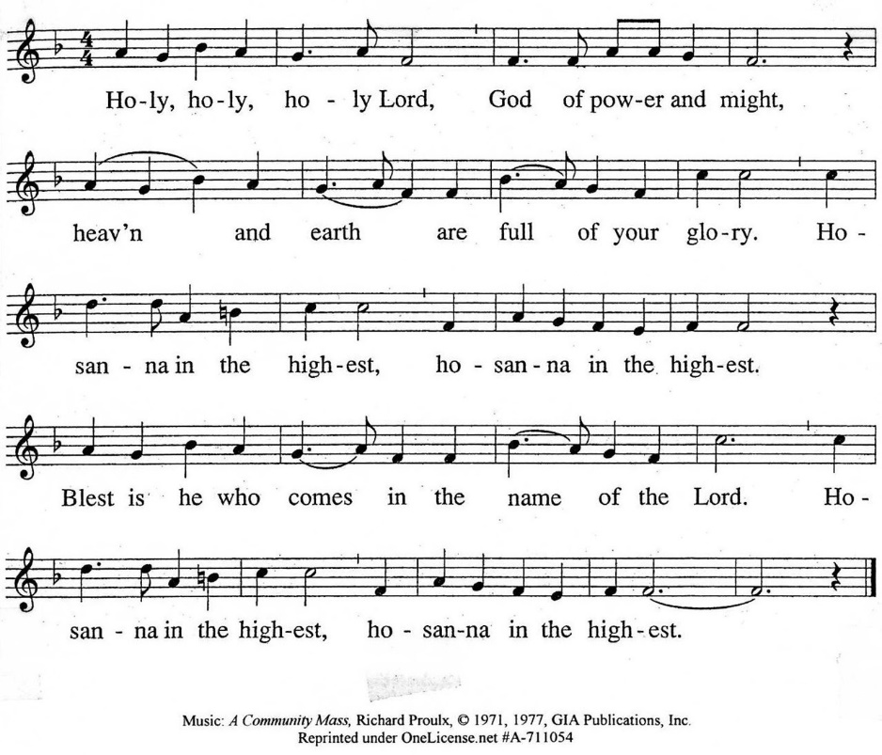

The minister continues the Thanksgiving…
“Together we proclaim the great mystery of faith:”
According to Christ’s commandment
We remember his death,
We proclaim his resurrection,
We await his coming in glory.

The minister continues with Intercessions for the Church and the World
and Prayers of the People…
Leader: Lord, in your mercy,
People: hear our prayers.
Our Lord’s Prayer
Our Father who art in heaven, hallowed be thy name. Thy kingdom come,
thy will be done, on earth as it is in heaven. Give us this day our daily bread;
and forgive us our debts, as we forgive our debtors; and lead us not into temptation, but deliver us from evil. For thine is the kingdom and the power
and the glory, forever. Amen.

Words of Institution
Communion
Communion Music: Elegy Alexander Arutiunian

We all will receive communion by coming to the Lord’s Table. Our usher will invite you to come forward by pew, beginning from the back. If you are unable to come forward, a server will come to you after everyone else has received. Please consume the elements when you are comfortable doing so. You do not need to wait – please do so as the Spirit leads (right away, as you pause after receiving, or back in your seats).
With Christian love we serve gluten-free communion bread and alcohol-free grape juice.
Also with Christian love the elements were prepared with strict attention to health concerns.
You are invited to partake of the prepackaged communion juice and wafer if you choose; the wafer is not gluten free.

Prayer after Communion
Hymn 475: Come, Thou Fount of Every Blessing (all verses)

Charge and Benediction
Leader: Now go and serve the Lord,
People: For we are blessed to be a blessing!

Postlude

Participants and Technical Crew
Rev. Wendy Boden
Liturgist: Pete Petersen
Greeter/Fellowship: Kathy Sanders and Barb Kocinski
Musicians: Tom Anderson, David Kozich
Worship Associate: David Kozich
Tech support: Chris Kozich, Blair Nelson

The flowers today are given by the Schmidt family celebrating Kevin’s 20th birthday..

If you are online, we’re glad to have you! Using the comments section on Facebook, you can say hello, ask for words of peace, or request prayers.
If you are present for worship, please wear a name tag; they are on the Mission shelf in the Narthex. Following the service, you are invited by the deacons to gather for in-person fellowship in the narthex.
Sunday Morning Adult Ed. Bible Study, 11:15 a.m.: If you’re at church and wish to join us, find Blair at his computer in the parlor/library. If you’re following us online, join the class by using this link: https://meet.google.com/fna-eojg-uye.
You are invited to join us on Facebook (https://www.facebook.com/SouthminsterGlenEllyn/), where we have a live sharing of “Heart to Heart” with Pastor Wendy Boden at 4:20 p.m. most weeks Tuesday through Friday. Note that Pastor Boden will be away July 17-23.
We continue to be live on Sunday morning for worship at 9:30 a.m. (slideshow beginning at 9:15) on YouTube at
https://www.youtube.com/channel/UCPgWICngOvkmR1OXgCG_wiA/live
or on Facebook at https://www.facebook.com/SouthminsterGlenEllyn/
If you are watching from home on Facebook, please check in and say hello so we can see that you have joined us. This is one way to make worship less “remote” and strengthen community at Southminster.
The live video will appear about 15 minutes before the scheduled start time.
If for any reason the feed falters, rest assured that a recording will be posted to Facebook and You Tube as soon as possible.

You can also find links to recordings of the weekday sessions, special services, and Sunday worship posted on our web site: https://www.southminsterpc.org/ or by going to our YouTube channel:
https://www.youtube.com/channel/UCPgWICngOvkmR1OXgCG_wiA/videos

Photo Stories/PowerPoints help us feel connected!
Photo Stories/PowerPoints help us prepare for worship, connect with one another, and make sure that our at-home people get both sound and sight. Here are some coming opportunities for you to share your photos:
August 25: “Doorways into Summer” – doors that you see during your summer travels
or simply around Chicagoland, even your own home. Please send photos by Thursday,
August 22.
October 6: “Communion Tables” – photos of communion tables from the places of
worship you visit while away on vacation or even ask a relative to send you a picture
Send photos to our dedicated email address, used just for photos:
PhotoStory@Southminsterpc.org. (If you only have hard copies of your photos, please leave them in the photo box on Pastor Wendy’s desk, labeled with your name and the date they are to be used.

Notes from Blair Nelson:
Adult Education: Our after-worship Bible class will meet today and the next two weeks (July 14 and 21). Join us in the Parlor/Library at 11:15 a.m.—bring your fellowship coffee with you and enjoy our study of Matthew’s gospel. To join us online, use this link: https://meet.google.com/fna-eojg-uye. The study is serious, but the fellowship is fun. Note that we won’t meet on July 28th, Aug. 4th, or 11th.
Men of Southminster: Men! Be sure you have this coming Saturday, July 13, 9:00 a.m., in your calendar for our next men’s get together.
Youth: Our next event is next Sunday, July 14 – our annual Fox River Naval Battle. Think a six-mile canoe trip downstream with squirt guns! This is a fun event for the whole family. Cost is $70/canoe (cash or check only), and we will meet at Ayer’s Landing (3494 East 2089th Rd., Ottawa, IL 61350—a little over an hour from Glen Ellyn) at 1:45 p.m. We will be on dry land by about 4:30 p.m. Be sure to let Blair know that you are in!
Southminster’s Youth Mission Team: Our Youth Mission Team has returned from Dexter, Maine, tired, sore, and satisfied. We traveled, worked, worshipped, fellowshipped, played, and had a great time doing it all. Be sure see photos in the July Dialog and talk to the team members about their experiences! This year’s team members were Samantha Falkman, Lauren Hammer, Kevin Schmidt, Landon Behm, Jake Falkman, Noah Salins, Nalani Johnson, Kathy Sanders, Parin Schmidt, and Blair Nelson.
From the Mission Ministry:
We’re having a “kitchen shower” for World Relief!
Imagine how it would feel to arrive in the United States as a refugee with nothing but what you were wearing and maybe carrying a bag or two. Throughout the month of July, our Mission Ministry will work with World Relief to host a “shower,” collecting items a refugee family would need to equip a kitchen. We will have bins in the coat room, and you can bring donations in any time this month.

Please consider donating from the following list:
1 set of mixing bowls 1 set of baking pans/dishes
1 saucepan/pot & 1 frying pan 1 set of cooking utensils
measuring cups & spoons medium/lg cutting board
manual can opener 3 kitchen towels
3 dishcloths silverware for 4
dishes for 4 (plates & bowls) 4 drinking glasses and 4 mugs
rice or pressure cooker tea kettle
1 toilet brush 1 broom & dustpan
1 plastic laundry basket 1 pad of paper
5 pens/pencils 1 electric fan
1 small toolkit 1 travel sewing kit
1 flashlight & batteries 1 alarm clock

World Relief asks that all items be new to preserve the recipients’ dignity. If we receive duplicates, World Relief will store them to distribute to other refugee families. Thank you for helping refugee families in need.
From the Worship Ministry:
The flower chart for the remainder of 2024 is posted in the narthex, and there are still a number of Sundays available. (July 21 is still available.) Please sign up in person or email Sarah Allen, sarah.cleland.allen@gmail.com with your choice of flower dates and honoree. Flowers remain $35.00 per arrangement. Thank you for your support of the Flower Ministry at Southminster.

Jubilee Bucks: Order today, July 7!
Today is your only chance this month to order Jubilee Bucks gift cards. Gift cards can be gifts, yes, but they can also be used for purchases you regularly make for yourself, like for groceries and gas. Southminster receives a small rebate from each card purchased, so buying Jubilee Bucks is a win-win for you and for the church! Email your order to bobbifrey@aol.com (or text herm if you have her cell phone number) any time before 9:00 tonight. You can pay when she delivers the cards.
Many thanks to all who order Jubilee Bucks. So far this year, the church has earned $938.38 in “free” money from those orders!
Donations for PRC (People’s Resource Center):
Our weekly donations to PRC are very much appreciated! If you are looking for ideas to donate, they are presently in need of tuna, canned spaghetti or stew, bags of rice, pasta. There are also lists of suggested donations printed on bright green paper in one of the literature stands on the shelf in the main hallway that is across from the church offices.
Care Notes: “In everything by prayer and supplication with thanksgiving let your requests be made known to God.” -Philippians 4:6
Even though we aren’t all together for worship, we are still collecting prayer requests! Please email or leave a message on our answering machine at 630-469-9149 if you won’t be present to fill out a prayer request slip.
Friends,
You are all invited to offer prayer for people whether they are members or not. It would be a joy and very helpful to know how people are doing. If you have submitted a person to be prayed for, please send an update to the office once in a while. Thank you! Pastor Wendy
New requests and updates are italicized in our prayer list.
Joys and Concerns
The flowers today are from the Schmidt family to celebrate Kevin’s 20th birthday.
We give thanks to God for joys.
- Our Youth Mission Team for a successful and spirit-filled week of service in Dexter, Maine.
- Meagan Severson had successful cancer surgery in Texas and is now home recovering in Alaska.
We pray for the whole world and our nation:
- Peace for Haiti and Sudan; Hamas, Israel, the people of Palestine, and the tangle of interests in the Middle East; Ukraine and Russia
- Pray for the American people
- We pray for an end to gun violence in our nation. On just one day – last Sunday, June 30 – there were 113 incidents of gun violence in 34 states plus the District of Columbia, killing 36 people and wounding 108 others. To see current statistics for shootings in our country go to https://www.gunviolencearchive.org.
- We pray for our nation as we continue to wrestle with race relations.
- We continue to pray for peace in the world
- For the Cuba Partnership Network as they seek passports for Cuban pastors and spouses for their meeting, which is in Oak Brook in September
Blessed are those who mourn:
- Prayers for the family and congregation of Pastor Abel in Cuba on the death of his eldest son, Abelito, who died in the hospital last week.
- For the families and friends of Ruth, Grace, Ed, Dan, and those we name in our hearts and hold dear.
We lift up those who are affected by cancer, as well as their support systems:
Please help us pray for your family and friends by updating your loved ones’ information with the church office. We support them and you in their journey.
- Prayers for Jason Burris, brother-in-law of Pete and Pam Petersen, who is now in hospice care as a result of brain cancer
- Lynn Ferino asks prayers for her good college friend, Cis, who has been newly diagnosed with an aggressive form of cancer.
- We continue to pray for: Frank B., Katie B., Pam G., Tom G., Frank L., Jean K., Jan M., Nikki M., Rebecca M., Tim O., Laura P., Gerry S., Marta S., Meagan S., Beverly W., Shelayne, and others we name in our hearts.
We pray for all who are recovering or dealing with mental or physical health or other challenges:
- Pray for Caroline Linde, who is in the hospital. Please, no visits or phone calls.
- Esther, recovering from surgery
- Phyllis Lay, hospitalized in Florida
- Heidi Shierry, continuing health issues
- Carmen (sister of Pedro Luis Laza in Cuba), who had a stroke and is recovering at home
- Brandon, a young man with liver damage
- Prayers for all who are looking for meaningful employment
- Mya, an 11-year-old who is suffering from an auto immune disease
- All those who have medical concerns and upcoming medical procedures
- Isabella, awaiting a kidney donor
- Oaklen, a grandchild of a friend of Tricia Smith, who has birth defects
- Sandy Phee asks prayers for Linda Talaga, who is now blind in both eyes.
- Prayers for healing, strength, and peace for Dan, a neighbor of Ann Anderson
- All those who are experiencing chronic pain.
- For those who are depressed
- Jim Smith, at Brookdale, and all who are in care centers
- Difficult marriages
- We continue prayers for those in hospice care: Gail Johnston at Du Page Convalescent Center (If you send a card to Gail, please mail it to Andrea Schmidt, whose address is in the directory.); former President Jimmy Carter; Barb’s friends Vicki and Bill (a married couple who both entered hospice care at the same time); Barb’s Aunt Ruth.
We pray for the Jeremiah 29 discernment task force and all of us as we seek God’s will for Southminster in the 21st century. May we all be attentive to the Holy Spirit’s leading.
Prayers for our worshiping community as we discern together God’s call on SPC for the 21st century.
Caring for you!
Our Congregational Care Committee is ready to assist in time of need. If you need assistance from the Congregational Care Ministry or Helping Hands in July, call Lynn Ferino (630-272-2269). You may call Pastor Wendy Boden on her cell or home phone (if she has shared the numbers with you) or leave a message for her at the church office: 630-469-9149. Email Wendy at wendy@southminsterpc.org. (Please note that she can only read email when she is in the office.) You may also call your deacon if you need help from the church.
Church staff will be away…
Administrative Assistant Barb Doppelt will be away this week (July 8-12). No one will be in the office on a regular basis, but Barb can still check email messages from home. There will be no eNotes this Wednesday.

Pastor Wendy Boden will be away July 17-23. For Pastoral Care while she is away, contact Minister of Youth and Adult Discipleship Blair Nelson at 630-917-6035. She will not stream Heart to Heart while she is away.
Grace and peace to you! Remember that we love God, neighbor, and one another. Our address is 680 South Park Blvd., Glen Ellyn, IL 60137 if you would like to set up an online account with your bank or mail in your pledge. Online giving through Vanco is also now an option –for details contact Ron Birchall.
Dates to remember this week:
All of July – collection of items for World Relief Kitchen Shower
Sunday, July 7
Order Jubilee Bucks gift cards by emailing bobbifrey@aol.com before 9:00 p.m.
Worship at 9:30 a.m. with communion - in person and also live on Facebook.
In-person Fellowship in the Narthex following the meeting
Staff meeting at 11:00 a.m. in the Pastor’s Office
Adult Ed. at 11:15 a.m. either online via Google Meet or by joining Blair
in person in the McHenry Parlor/Library
Confirmation at 11:15 a.m. in the pastor’s office
Pathfinders Online Group at 12:15 p.m.
No Youth Group activity
Monday-Friday, July 8-12 – Barb will be away
Monday, July 8 – Pastor’s Sabbath
Tuesday-Friday – Pastor Wendy’s Heart to Heart on Facebook live at 4:20 p.m.
Tuesday, July 9
A.A. meets at 7:30 p.m. in Fellowship Hall
Wednesday, July 10
No eNotes while Barb is on vacation
Friday, July 12
A.A. meets at 6:30 p.m. in Fellowship Hall
Saturday, July 13
Men of Southminster meet at 9:00 a.m. in McHenry Parlor/Library
Next Sunday, July 14
Worship at 9:30 a.m. - in person and also live on Facebook.
In-person Fellowship in the Narthex following the meeting
Staff meeting at 11:00 a.m. in the Pastor’s Office
Adult Ed. at 11:15 a.m. either online via Google Meet or by joining Blair
in person in the McHenry Parlor/Library
Confirmation at 11:15 a.m. in the pastor’s office
Youth: Our annual “Fox River Naval Battle” (canoeing on the Fox River)! Meet
at 1:45 p.m. at Ayers Landing in Ottawa, IL.
Bearing Fruit – July 7, 2024
Welcome, Jessica

How have you seen God at work in our church?
At our most recent officer meetings we talked about God sightings – what we have seen God doing in our midst. In August, some of the slideshows will be pictures of what we sense God is doing in our midst. Our youth have returned from a mission trip – they have God sightings. Our Cuba mission team has returned, and they have God sightings, as well.
Some of our God sightings are closer at home. We have children, babes in arms, in our church family now, and we have concluded our process of hiring a nursery worker. We haven’t had a need for a nursery worker for a long while. For now, one side of the room will be for the babes and toddlers and the others side of the room will be for Sunday school.
Please welcome Jessica Abuseini. Jessica is excited to get to know the families of our congregation. She has over 5 years of experience working with children, especially in the ranges of infants to toddlers, and as a mother herself, Jessica is ready to bring her expertise in providing care for families during Sunday service. After graduating with a Bachelor of Psychology degree and being inducted into the national honor society of psychology, she felt a strong pull from God to find a job engaging with children, and she has been following God’s message since. Please feel free to stop by the nursery and introduce yourself to her, as she is excited to get to know everyone.
What are some of the ways that you have seen God working in us, through us, or calling us to in the 21st Century? In all these things we seek to bear the fruit of God’s love.

